ECDO scientific committee (2006)

Wilfried Bursch, Institute of Cancer Research, Medizinische Universität, Vienna, Austria
Amedeo Columbano, University of Cagliari, Department of Toxicology, Cagliari, Italy
Klaus-Michael Debatin, University Children's Hospital, Ulm, Germany
Wim Declercq, Department for Molecular Biomedical Research, Ghent University, Belgium
László Fésüs, University of Debrecen, Debrecen, Hungary
Marie-Lise Gougeon, Institut Pasteur, Paris, France
Marja Jäättelä, Institute for Cancer Biology, Apoptosis Department, Copenhagen, Denmark)
Peter Krammer, German Cancer Research Centre, Heidelberg, Germany
Guido Kroemer, Institut Gustave Roussy, Villejuif, France
Seamus Martin, Trinity College, Molecular & Cell Biology laboratory, Dublin, Ireland
Mauro Piacentini, University of Rome “Tor Vergata”, Rome, Italy
Hans-Uwe Simon, University of Bern, Bern, Switzerland
Zsuzsa Szondy University of Debrecen, Debrecen, Hungary
Boris Turk, Jozef Stefan Institute, Biochemistry and Molecular Biology, Ljubljana, Slovenia
Peter Vandenabeele, Department for Molecular Biomedical Research, Ghent University, Belgium
Boris Zhivotovsky, Karolinska Institutet, Stockholm, Sweden

Conference website
http://www.dmbr.ugent.be/ecdo/

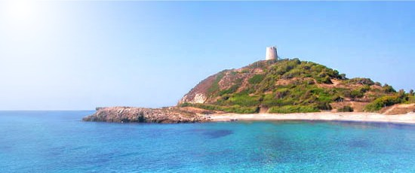
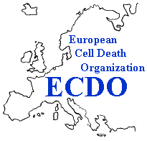
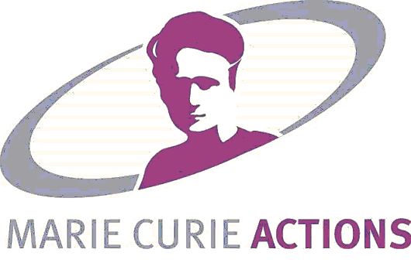
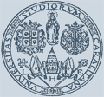
14th Euroconference
on Apoptosis
"Death or Survival?
Fate in Sardinia“

For detailed information, please visit http://www.dmbr.ugent.be/ecdo/

Deadline scholarship application:
May 31, 2006
3rd Training course on ”Concepts and Methods
in
Programmed Cell Death”
Chia, Sardinia, Italy
September 29-October 4, 2006
&
Supported by EC within the framework of the Marie Curie Conferences and Training Courses

Local Organisation

Amedeo Columbano
University of Cagliari
Department of Toxicology
Via Porcell 4
09124 Cagliari
Sardinia, Italy
columbano@unica.it
+ 39-070-675 8345
+ 39-070-666062

Mauro Piacentini
Univ. of Rome ‘Tor Vergata’
Department of Biology
Via della Ricerca Scientifica
00133 Rome
Italy
mauro.piacentini@uniroma2.it
+39-0672594234
+39-062023500

ECDO secretariat

Veronique Vandevoorde
Department for Molecular Biomedical Research
VIB-University of Ghent
Technologiepark 927
B-9052 Ghent (Zwijnaarde)
Belgium

Tel: +32-(0)9-33-13682
Fax:+32-(0)9-33-13511
e-mail: Veronique.Vandevoorde@dmbr.UGent.be
ecdo@dmbr.ugent.be
http://www.dmbr.ugent.be/ecdo/

14th Euroconference on Apoptosis
"Death or Survival? Fate in Sardinia"

ECDO's 14th Euroconference on Apotosis is organised in Cagliari, Sardinia, Italy, from September 29 (arrival) till October 4 (departure), 2006.

The conference will take place in Le Meridien Chia Laguna, close to some of the most beautiful beaches on Sardinia, that combines a large Conference center with a pleasant stay in cottage rooms, spread throughout the Mediterranean landscape.

Every year, we welcome about 300 people, from all over the world. The focus of the conference, the special attention for the poster presentations and short oral communications, the common lunches and social programs create an atmosphere of stimulating discussions and contacts. Therefore, the ECDO conferences are considered as one of the best meetings in the field of cell death research.

Thematic areas

The thematic areas that will be addressed in the Euroconference are:

*DNA damage and cancer | *ROS
*Inflammation | *ER stress
*Neurodegeneration | *Development
*Organelle cross-talk | *Autophagy

Special Lectures

Keynote address
Paolo Comoglio (Torino, italy)
ECDO Honoaray Lecture
Jurg Tschopp (Lausanne, Switserland)

Confirmed Speakers
A.Thomas Look (Boston, USA)
Peter Chumakov (Cleveland, USA)
Manuela Baccarini (Vienna, Austria)
Gerry Melino (Leicester, UK)
Andreas Strasser (Parkville, Australia)
Pierre Vanderhaeghen (Brussels, Belgium)
Atan Gross (Rehovot ,Israel)
Guido Kroemer (Villejuif, France)
John Blenis (Boston, USA)
Barbara Conradt (Hanover, USA)
Adi Kimchi (Rehovot, Israel)
Ruth Slack (Ottawa, Canada)
Frank Madeo (Graz, Austria)
Inohara Naohiro (Ann Arbor, USA)
Zhao Qi Wang (Lyon, France)
Pelicci Piergiuseppe (Milan, Italy)

Registration and call for abstracts
Participants are asked to preregister and submit their abstract before May 31, 2006. Registration fees covers admittance to lectures and poster sessions, abstract book, welcome reception, coffee breaks and local transport from the airport to the conference venue.

Registration Fee | Before August 15 | After August 15
Full registration ECDO members | 330 euro | 380 euro
Full registration non-ECDO members | 430 euro | 480 euro
Student ECDO members | 330 euro | 380 euro
Student non-ECDO members | 380 euro | 430 euro
Training Course | 100 euro | 100 euro

ECDO membership offers reduced conference registration fee and a free online subscription to Apoptosis for 2006. More information available at the ECDO website http://www.dmbr.ugent.be/ecdo/

Location
The conference will take place in Le Meridien Chia Laguna in Chia, situated about 50 km to the westside of Cagliari, Capital of Sardinia.
Late September, the weather is very mild in Sardinia and average temperature is 23-25° C.

3rd Training course on 'Concepts and Methods in Programmed Cell Death'

The 3rd Training course on Concepts and Methods in Programmed Cell Death is organised jointly with the 14th Euroconference on Apoptosis and will also take place in Le Meridien Chia Laguna on the first day of the conference (Saturday, September 30, 2006).

The aim of the training course is to introduce young scientists, who are newcomers, into the current concepts, methodologies and tools used in the study of programmed cell death.
The course consists of 6 lectures (60 minutes per lecture, including discussion time).

Speakers and topics
Jiri Bartek (Copenhagen, Denmark)
The Nuclear control of gene expression in cell death
Jean-Claude Martinou (Geneve, Switserland)
The Role of Mitochondria in cell death
Randal J. Kaufman (Ann Arbor, USA)
The role of ER stress and Translation in cell death
Kris Gevaert (Ghent, Belgium)
Proteomics of dying cells
Sharad Kumar (Adelaide, Australia)
Caspase biology and function
Eric Baehrecke (Maryland, USA)
Autophagy

Scholarships

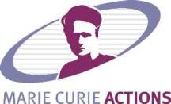
Thanks to the European Commission Marie Curie Actions Programme, scholarships are available for the 14th Euroconference on Apoptosis and/or the 3rd Training course on concepts and methods of programmed Cell Death. Eligibility guidelines can be found on the conference website. The ECDO Scientific Board will grant the scholarships on the basis of submitted abstracts and supplied scholarship documents. Deadline for scholarship application is May 31, 2006.

